EXPERIMENT 3

AIM:Draw a relational model for a college database

－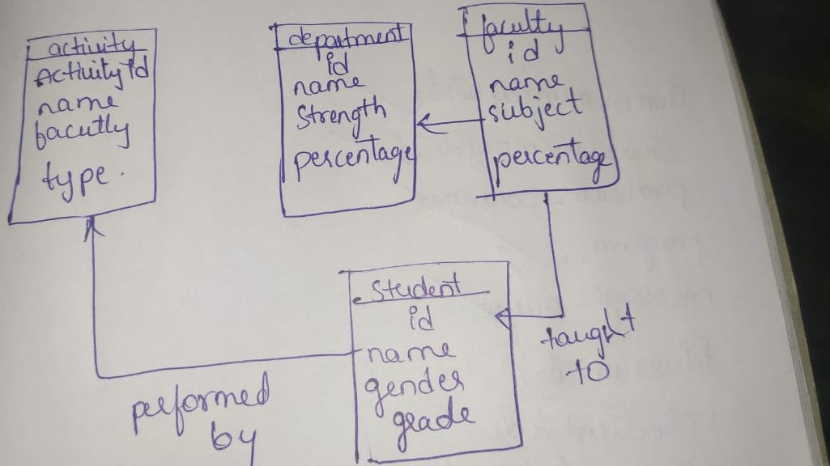

Department

ID

Name

Percentage

Student

ID

NAME

Gender

Grade

Faculty

Id

Name

Subject

Percentage

Activity

Activity id

Name

Faculty

Type